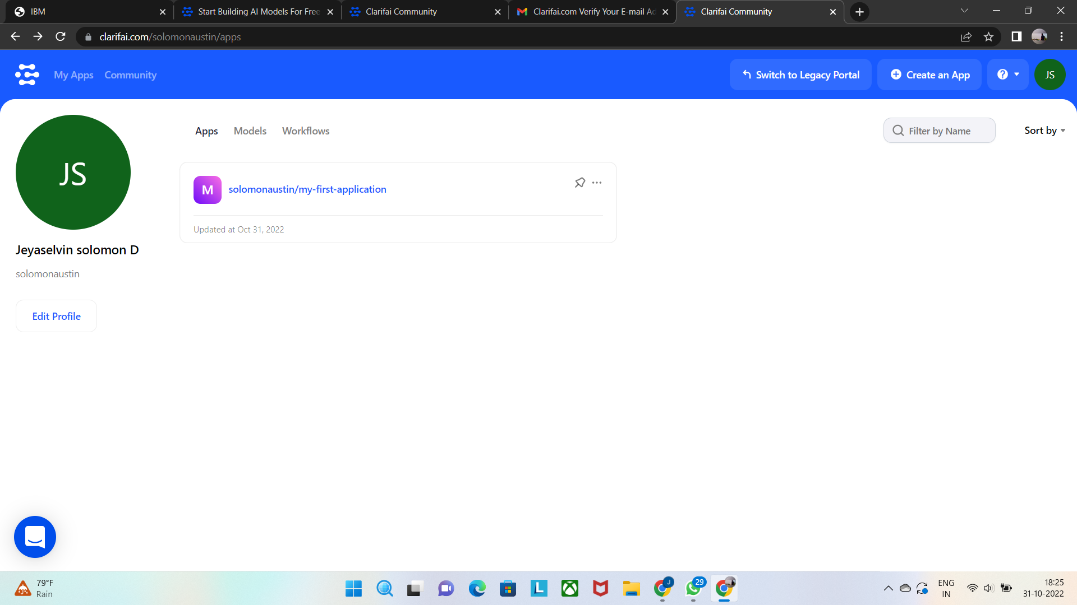

JEYASELVIN SOLOMON D

111519106058

Project:Create an

Account in clarifai